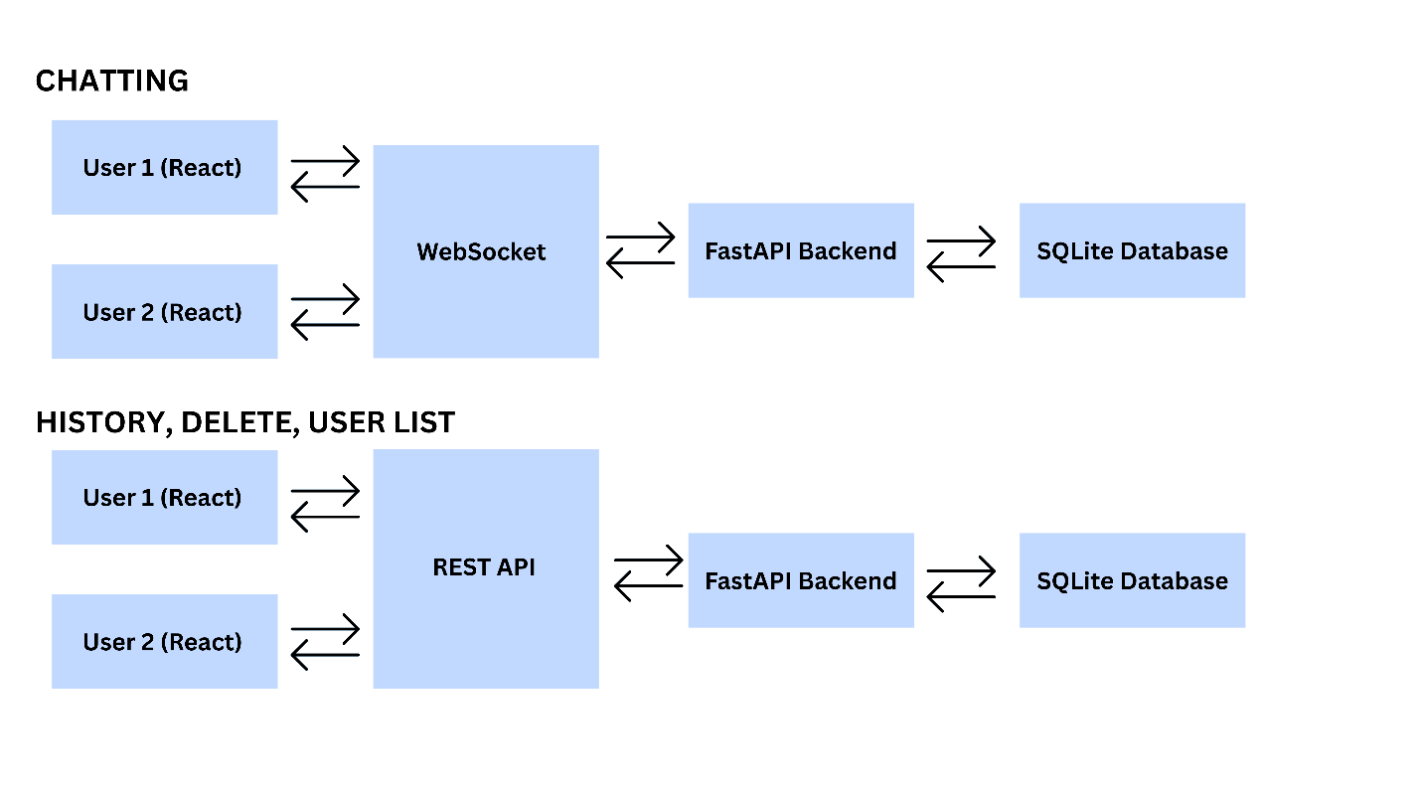

System Architecture Overview
The diagram illustrates the communication flow and architectural components of the chat application built with React (frontend), FastAPI (backend), and SQLite (database). The system supports both real-time and non–real-time operations through distinct communication mechanisms.
1. Chatting (Real-Time Communication)
In the chatting module, each React client establishes a WebSocket connection with the FastAPI backend. This enables real-time, bidirectional communication for message exchange between users. The backend manages message broadcasting and persistence by interacting with the SQLite database, ensuring that all chat messages are stored and retrievable.
2. History, Delete, and User List (Non–Real-Time Operations)
For operations that do not require real-time interaction—such as retrieving chat history, deleting messages, and fetching the user list—the React clients communicate with the FastAPI backend via REST API requests. The backend handles these requests, performs the necessary database operations on the SQLite database, and returns structured responses to the frontend.
Summary
This architecture provides a clear separation between real-time and standard API interactions, allowing for efficient, scalable, and maintainable communication between clients and the backend services.

